**ADVANCED SOFTWAR ENGINEERING**

ASSESSMENT -2

GRAPHICAL PROGRAMMING LANGUAGE

***Name : Rajan Shahi***

**Student id - 77202325**

**Version Control**

Version Conrol Commit Summary:

PROGRAM SCREENSHOT:-

***Graphical User Interface***:

*Main View :-*

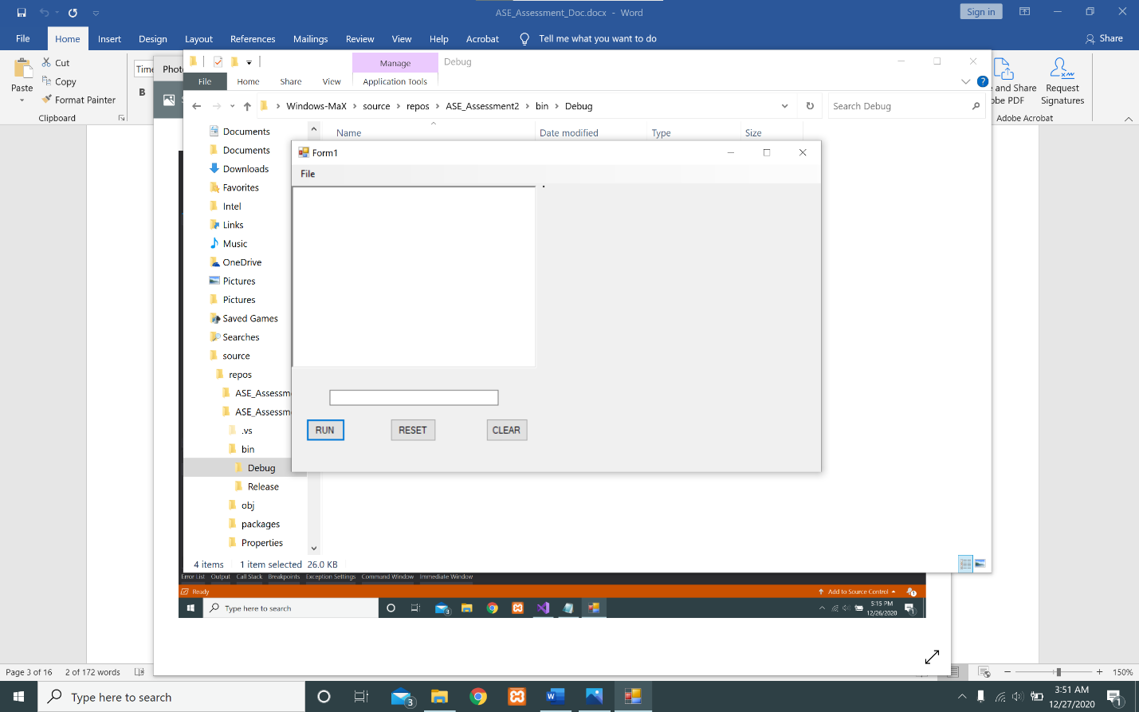

**Input-Command:-**

*Clear -Command*

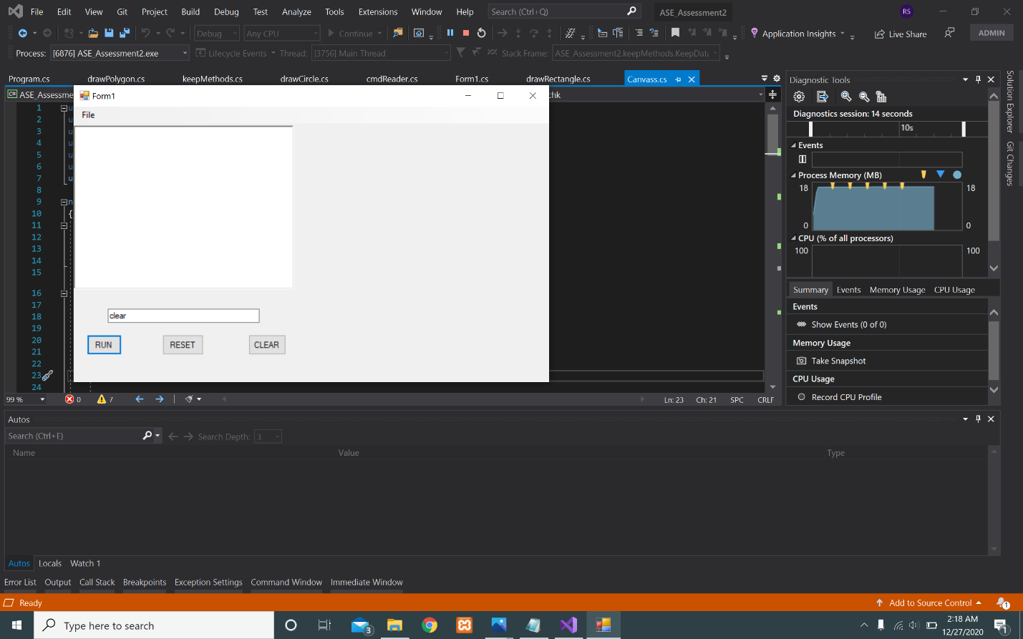

*Reset-Command:-*

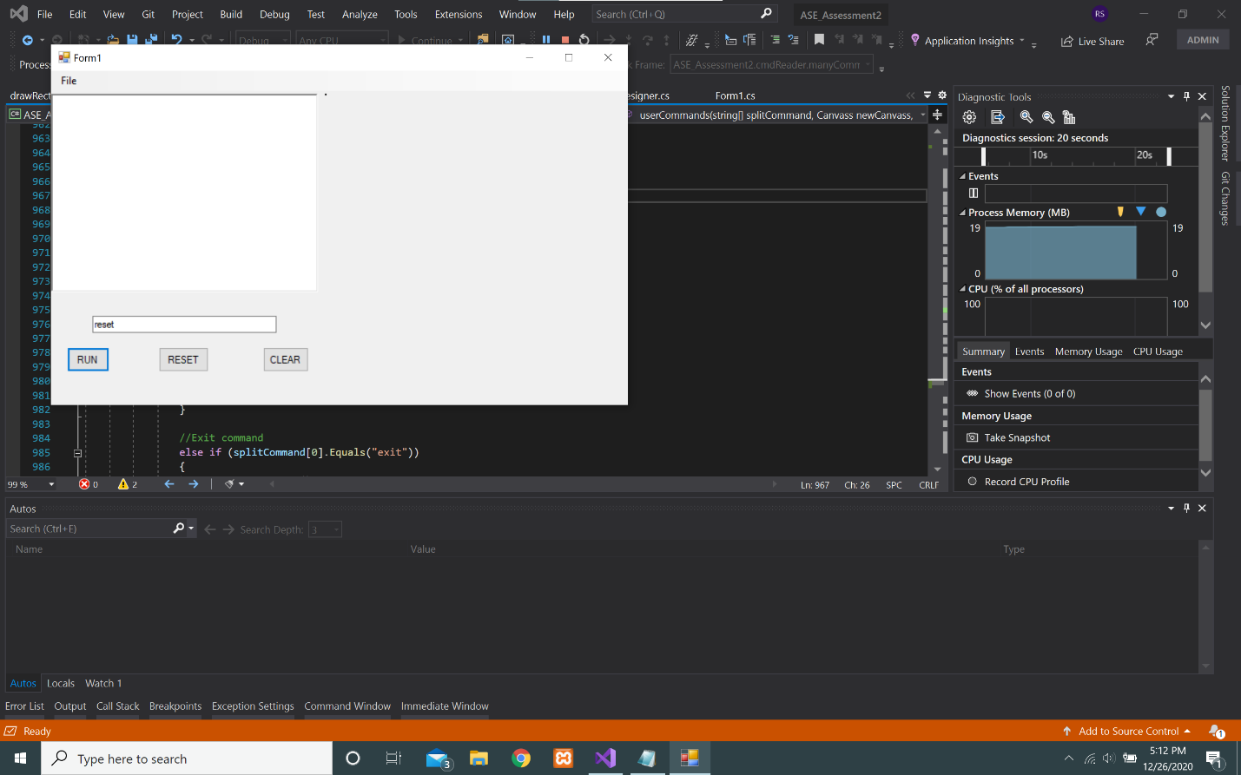

*Exit-Command:-*

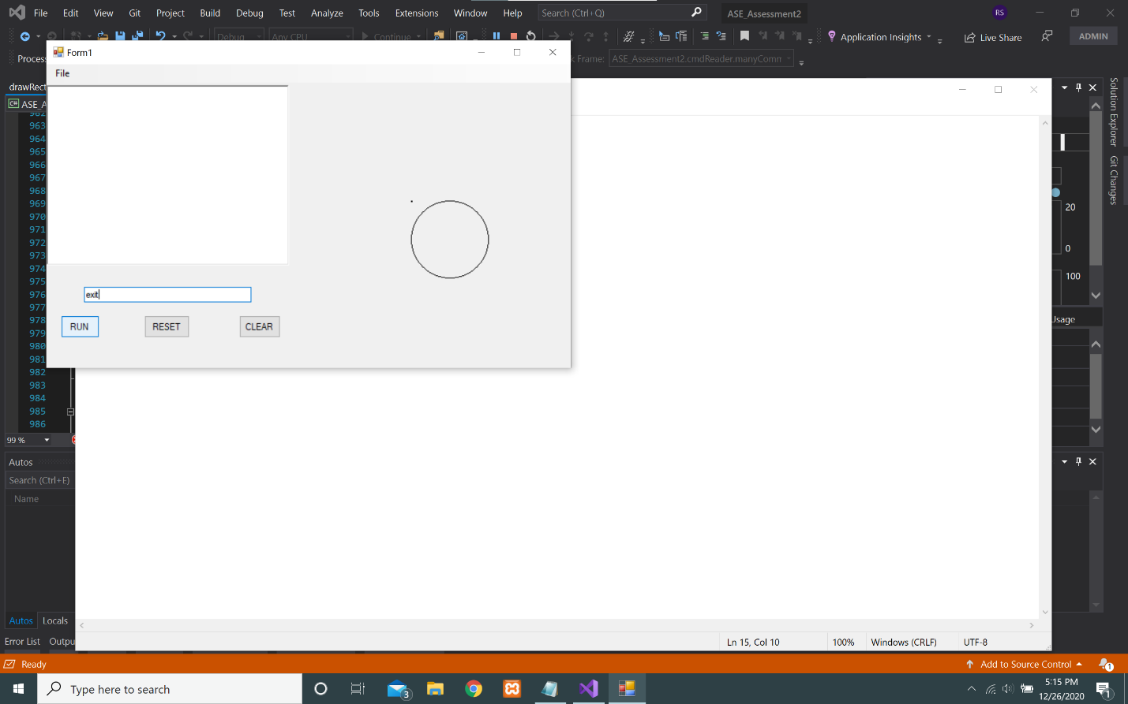

*Run-Command:-*

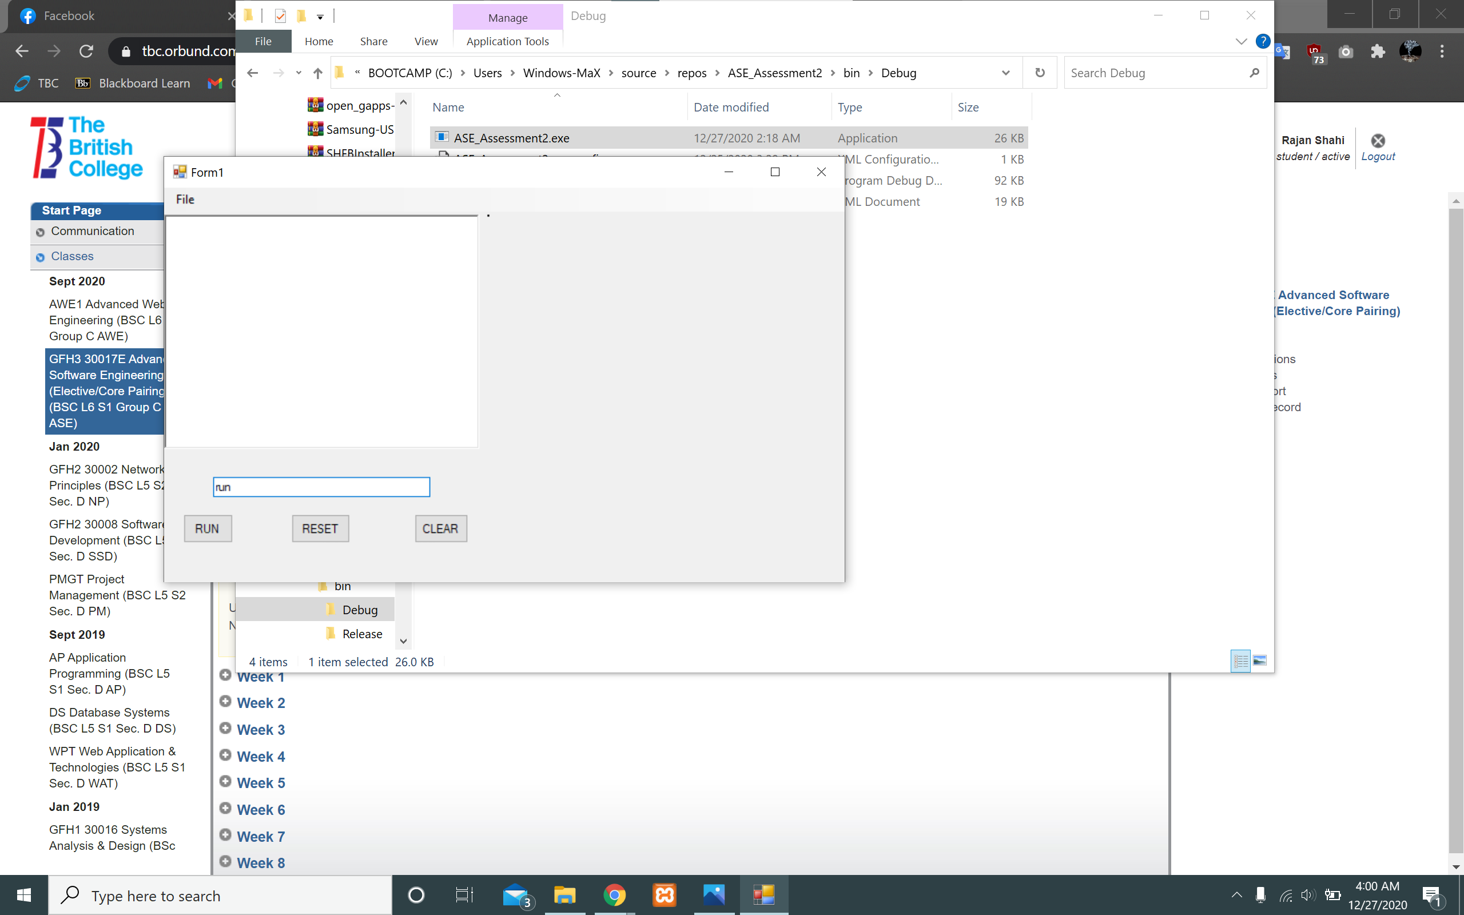

**Draw-Command:**

Drawto :

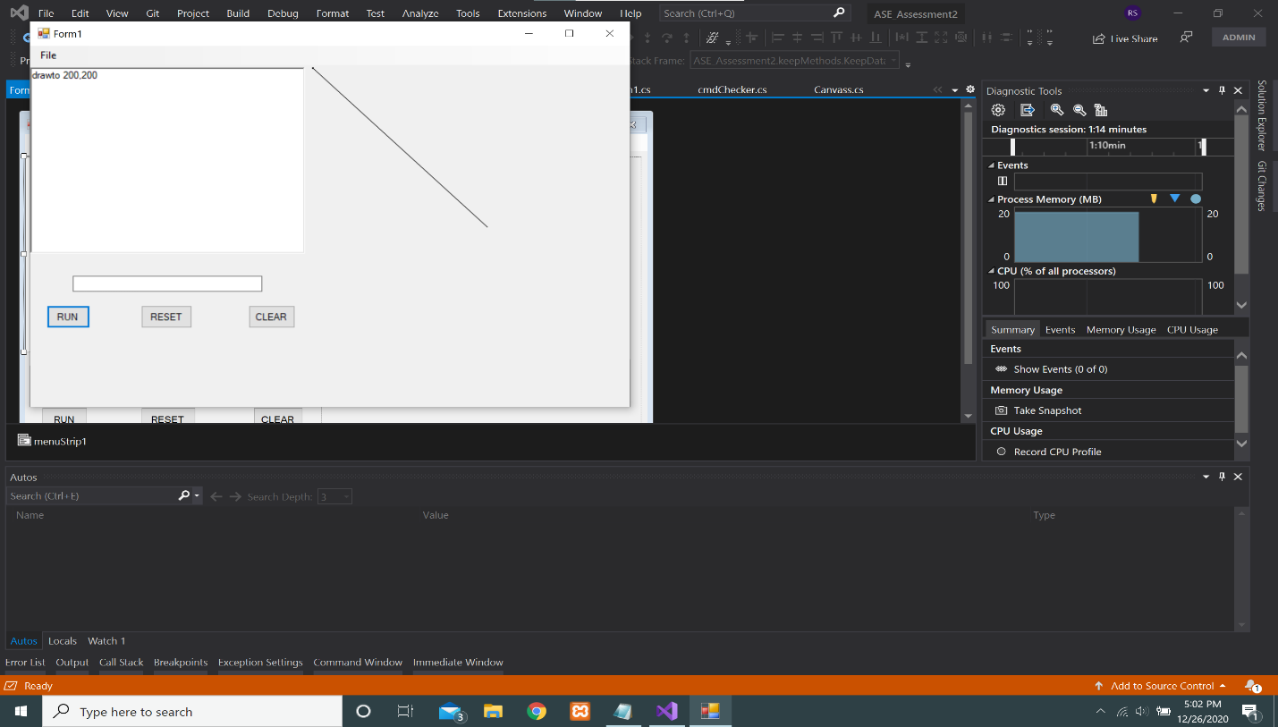

Moveto :

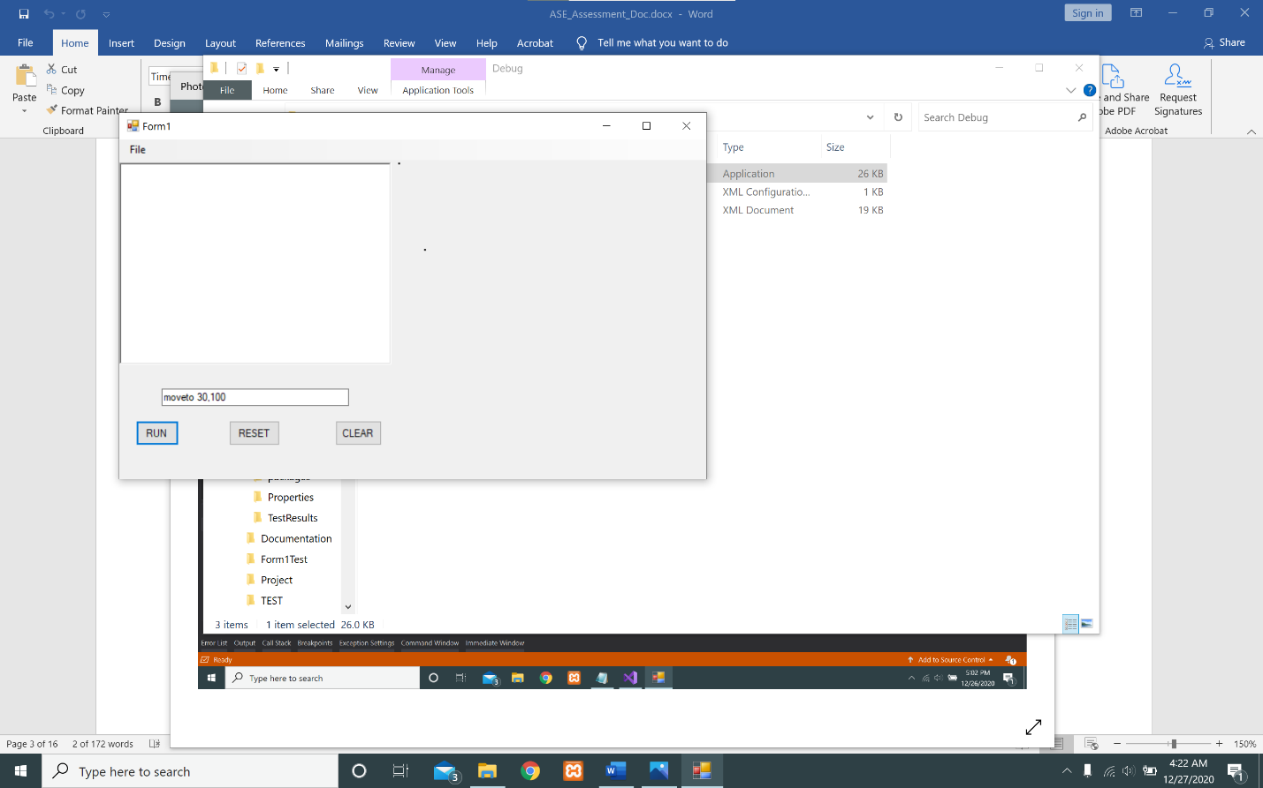

To DrawSquare :

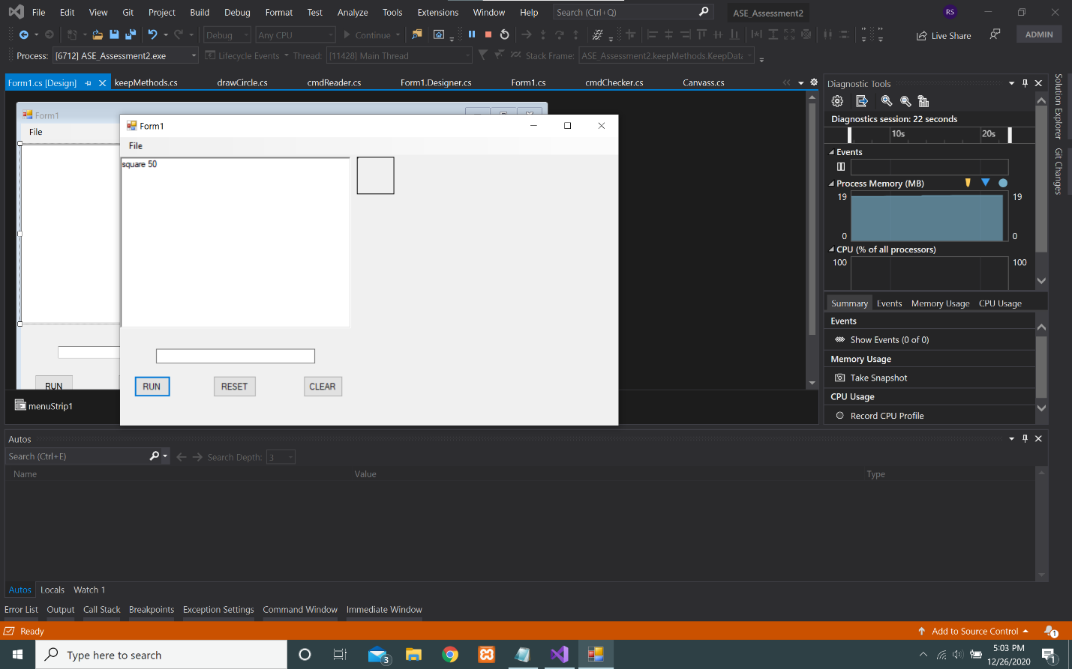

To DrawRectangle :

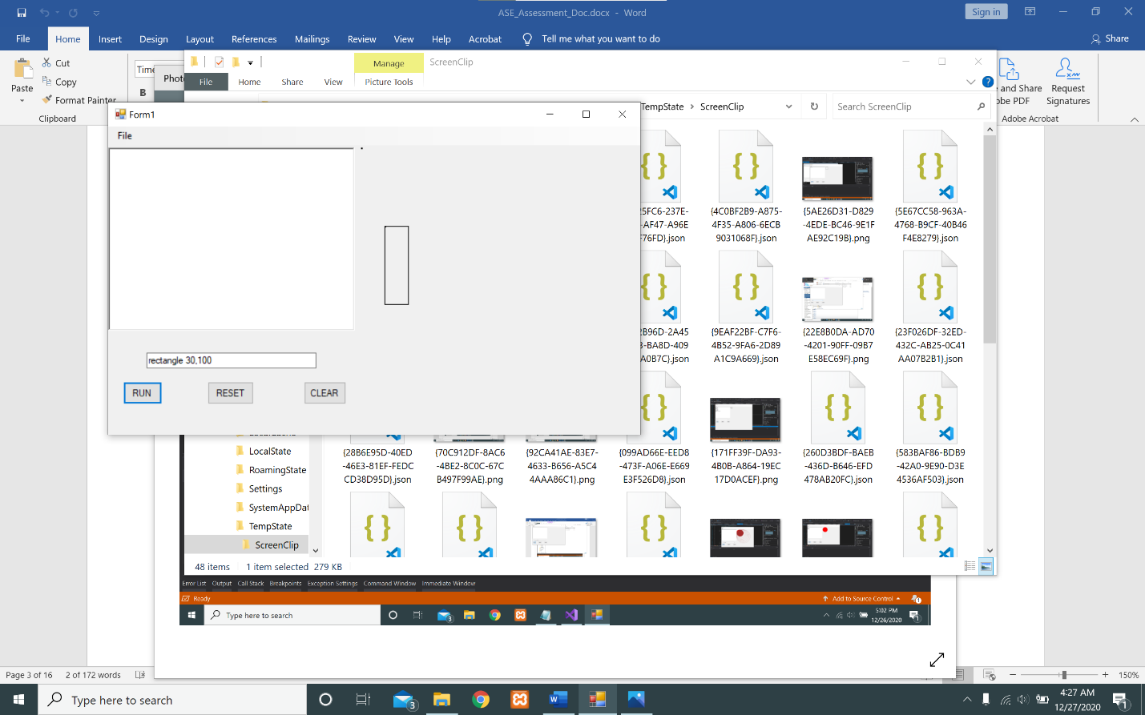

To DrawCircle :

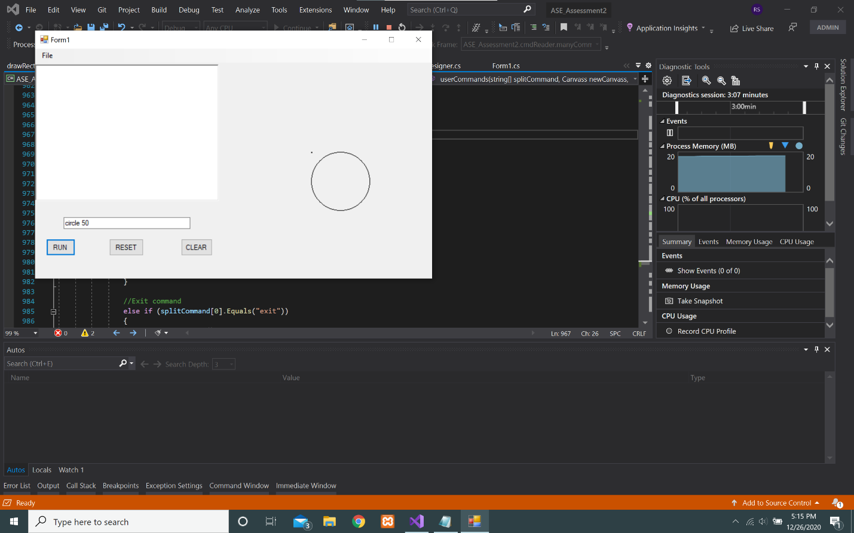

To DrawTriangle :

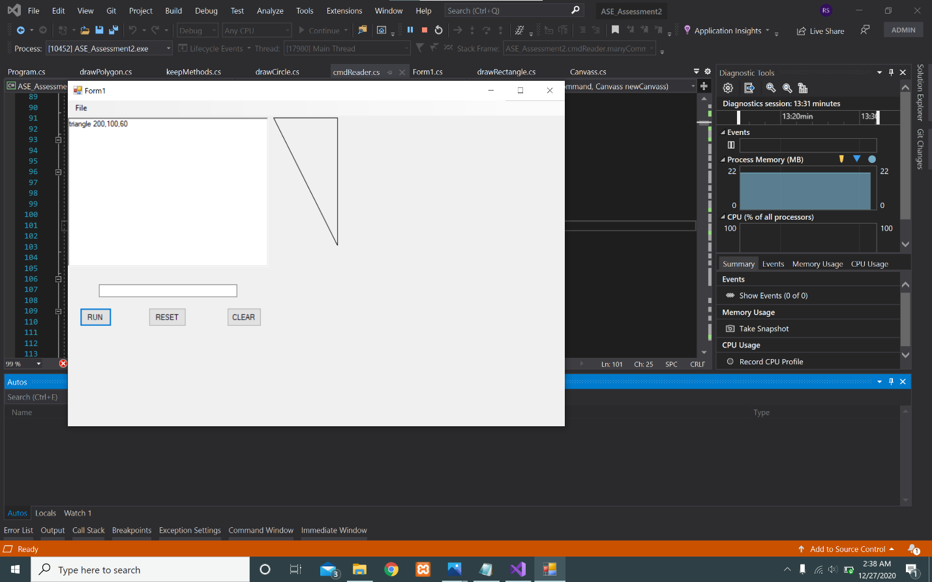

To DrawPolygon :

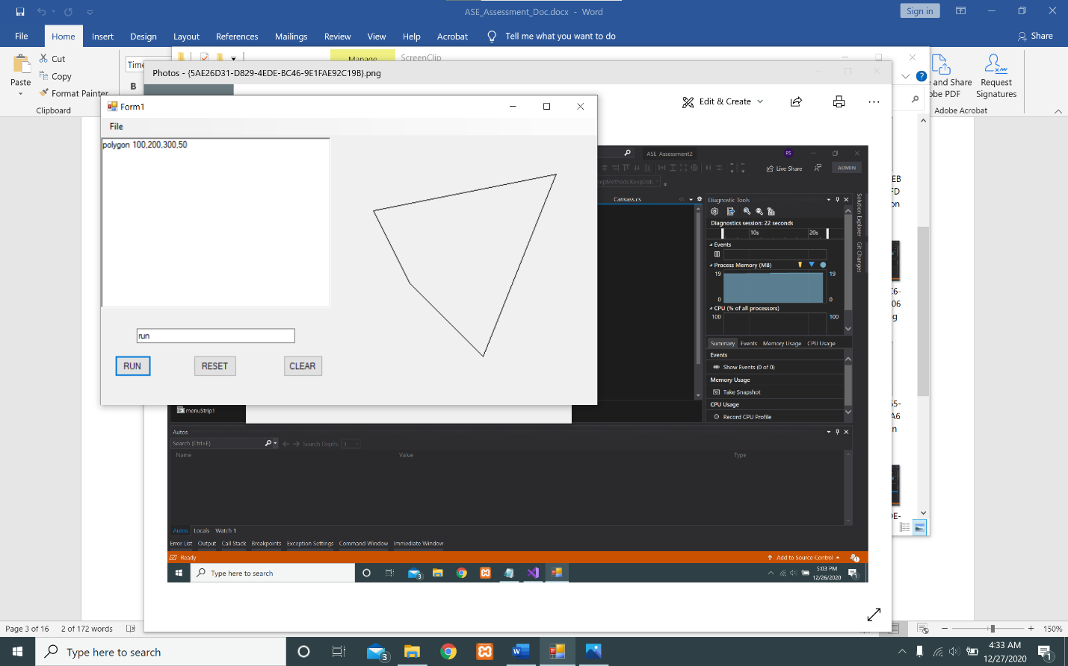

To Fill Color :

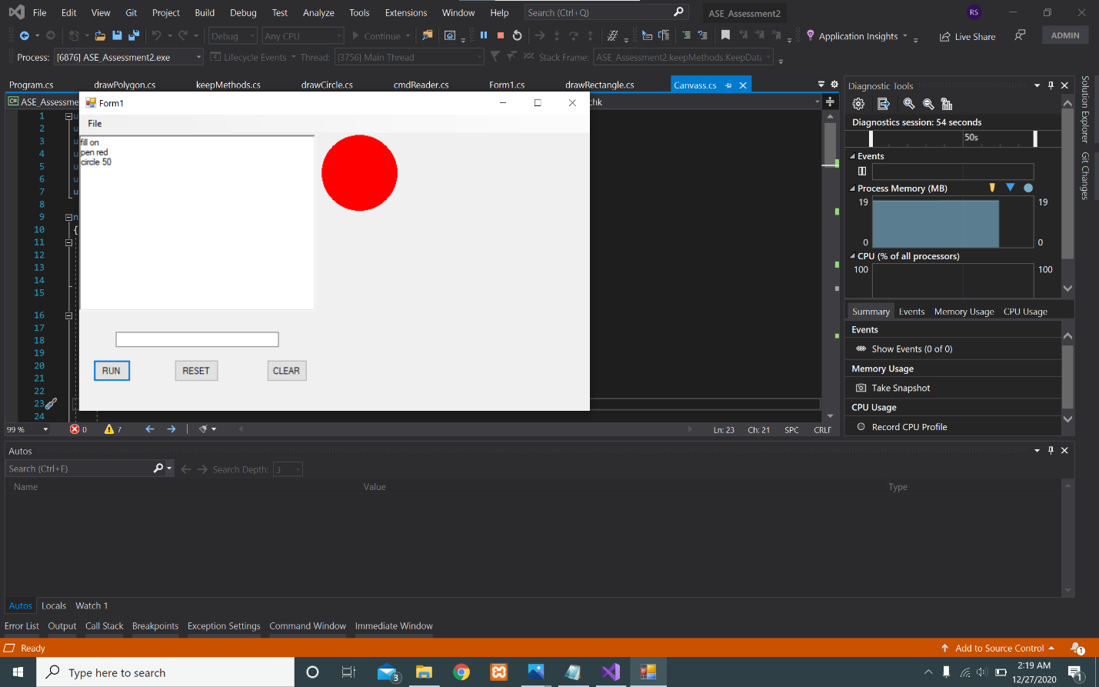

To Pen Color :

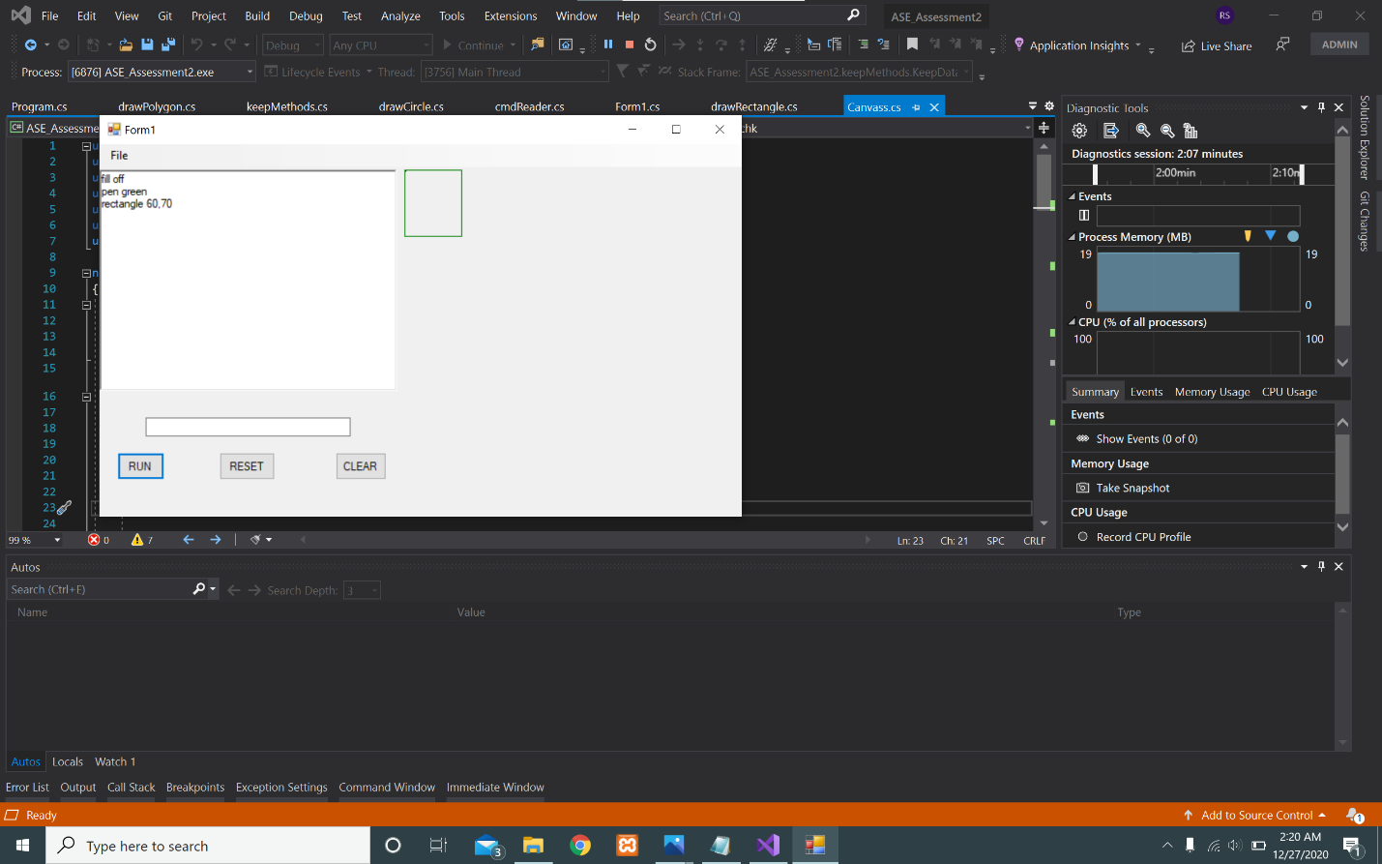

**Loop Command :**

For loop Command :

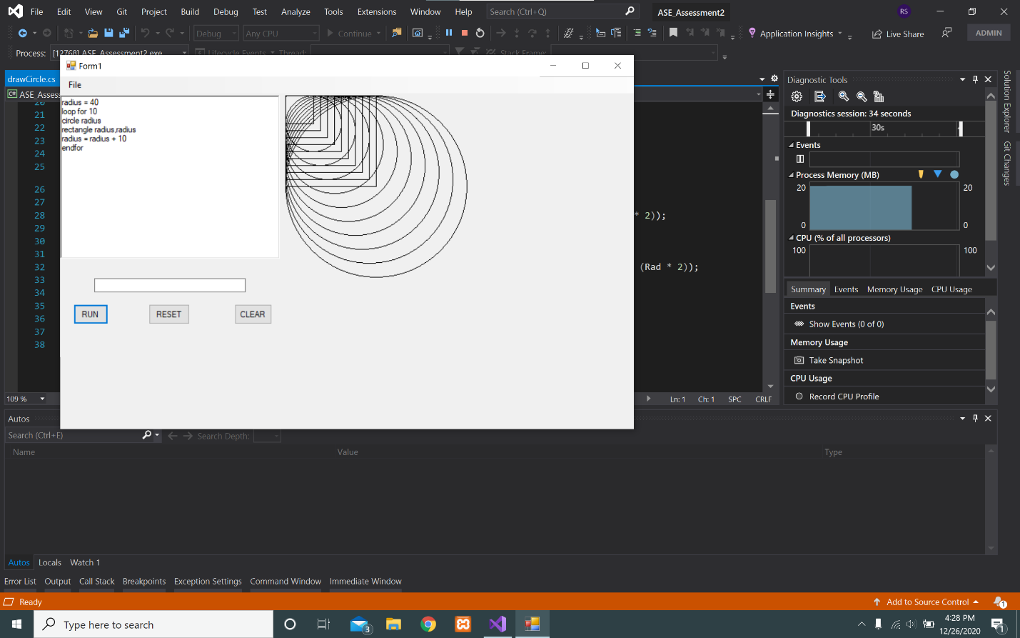

End if loop Command :

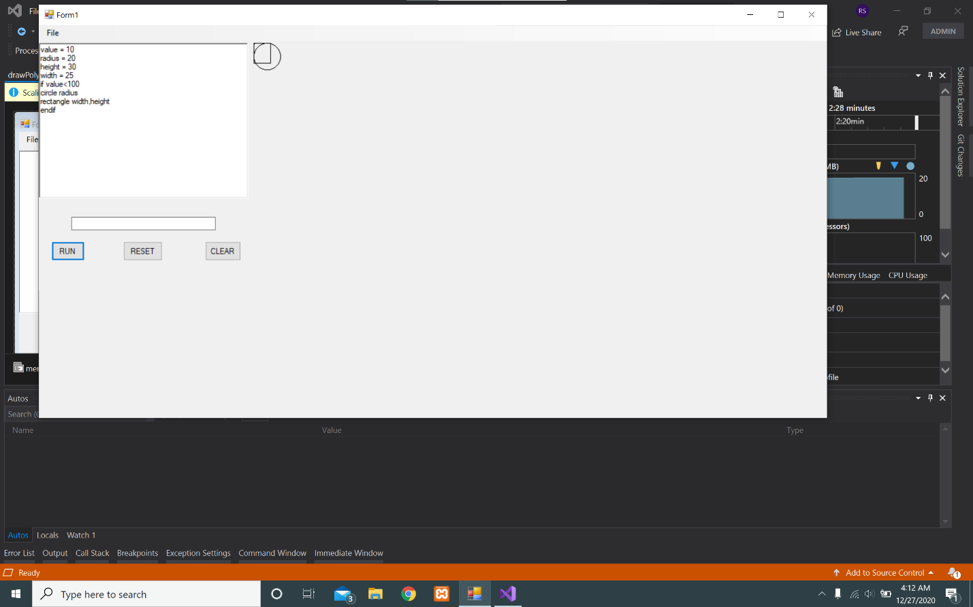

**Methods Command :**

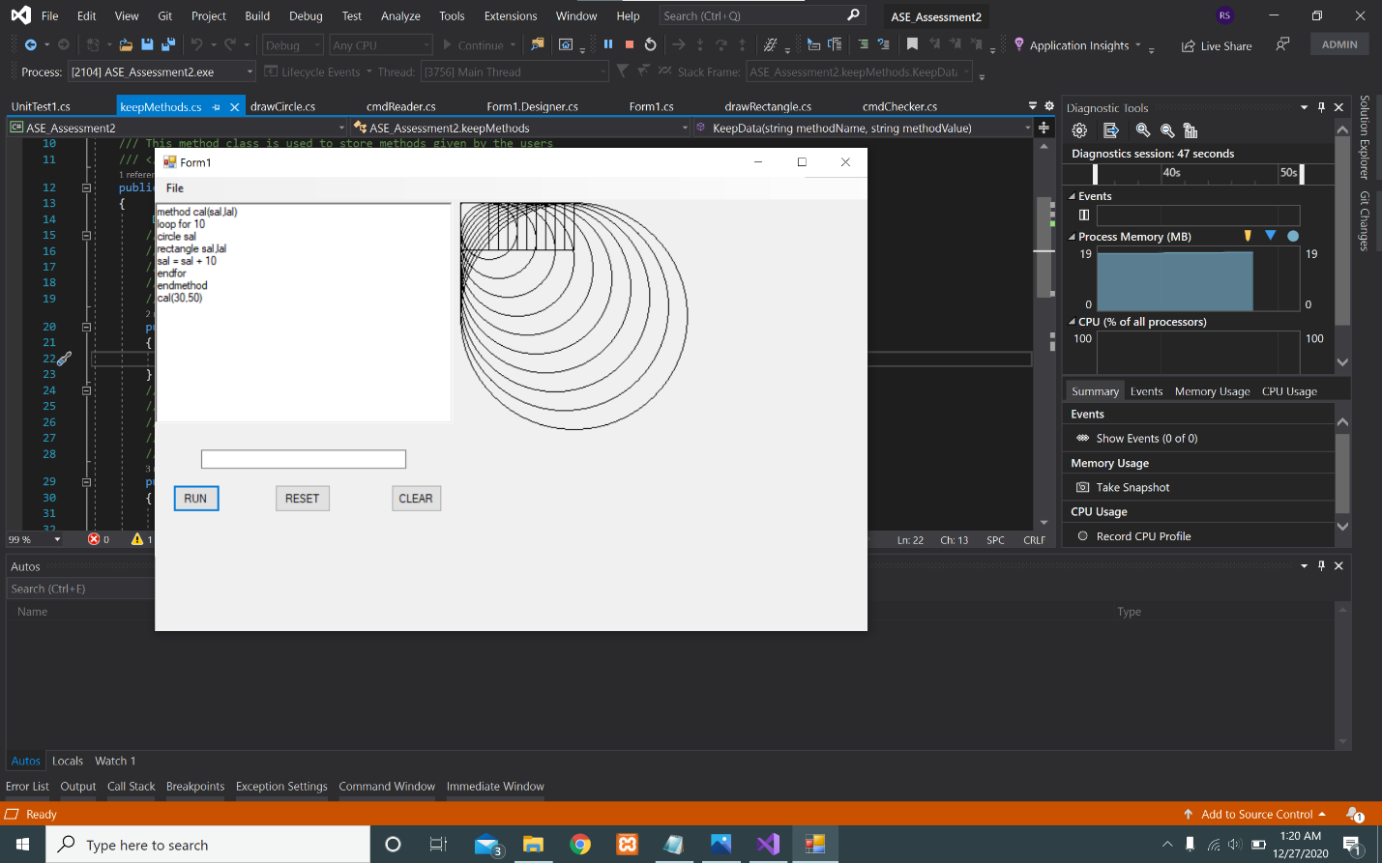

***PARAMETER AND SYNTAX VALIDATION:-***

***SYNTAX VALIDATION :***

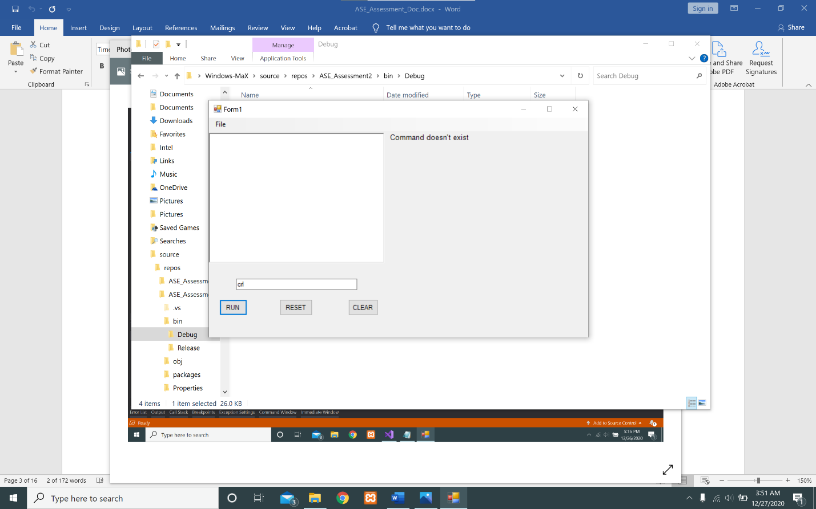

***SYNTAX VALIDATION :***

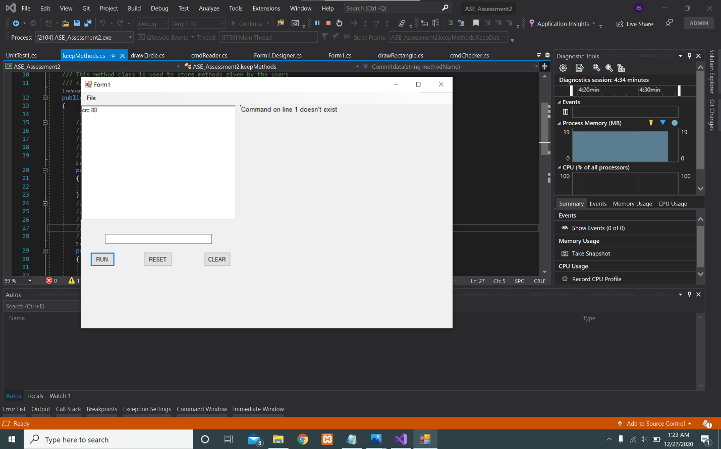

***PARAMETER VALIDATION :***

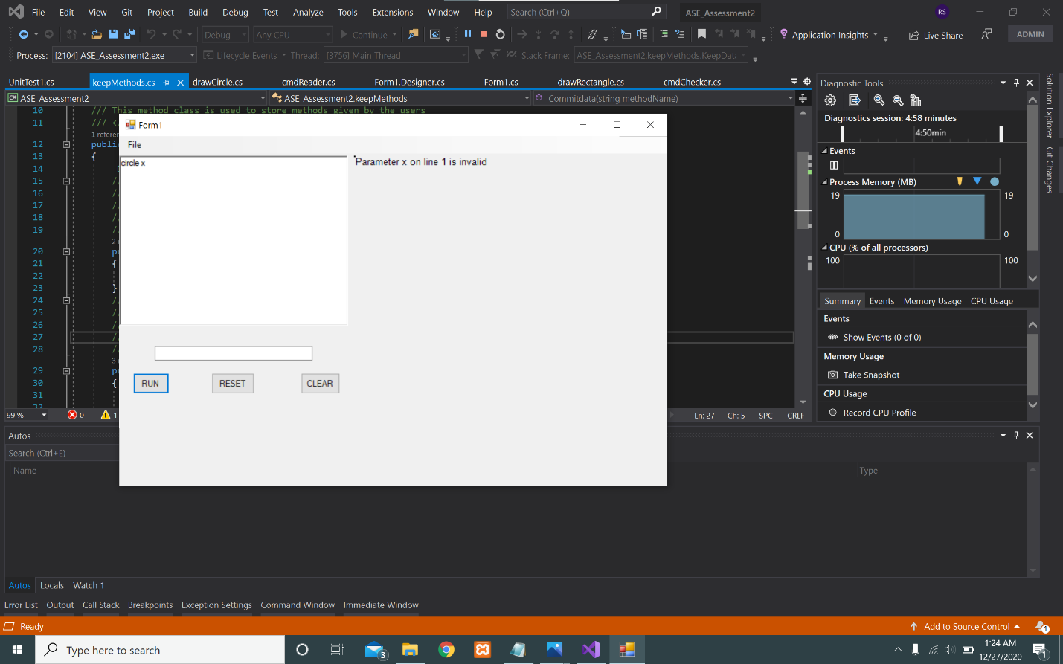

**Executing Known _Command Line:**

**Fill and pen Color**

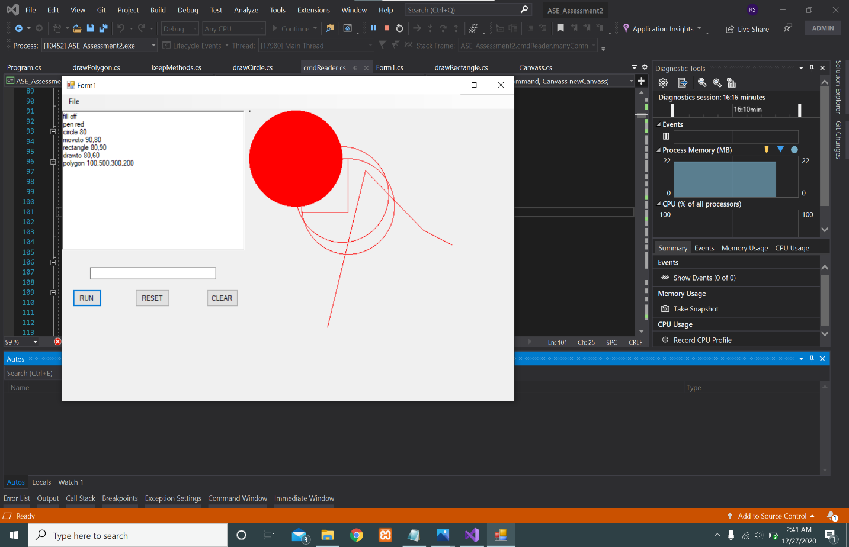

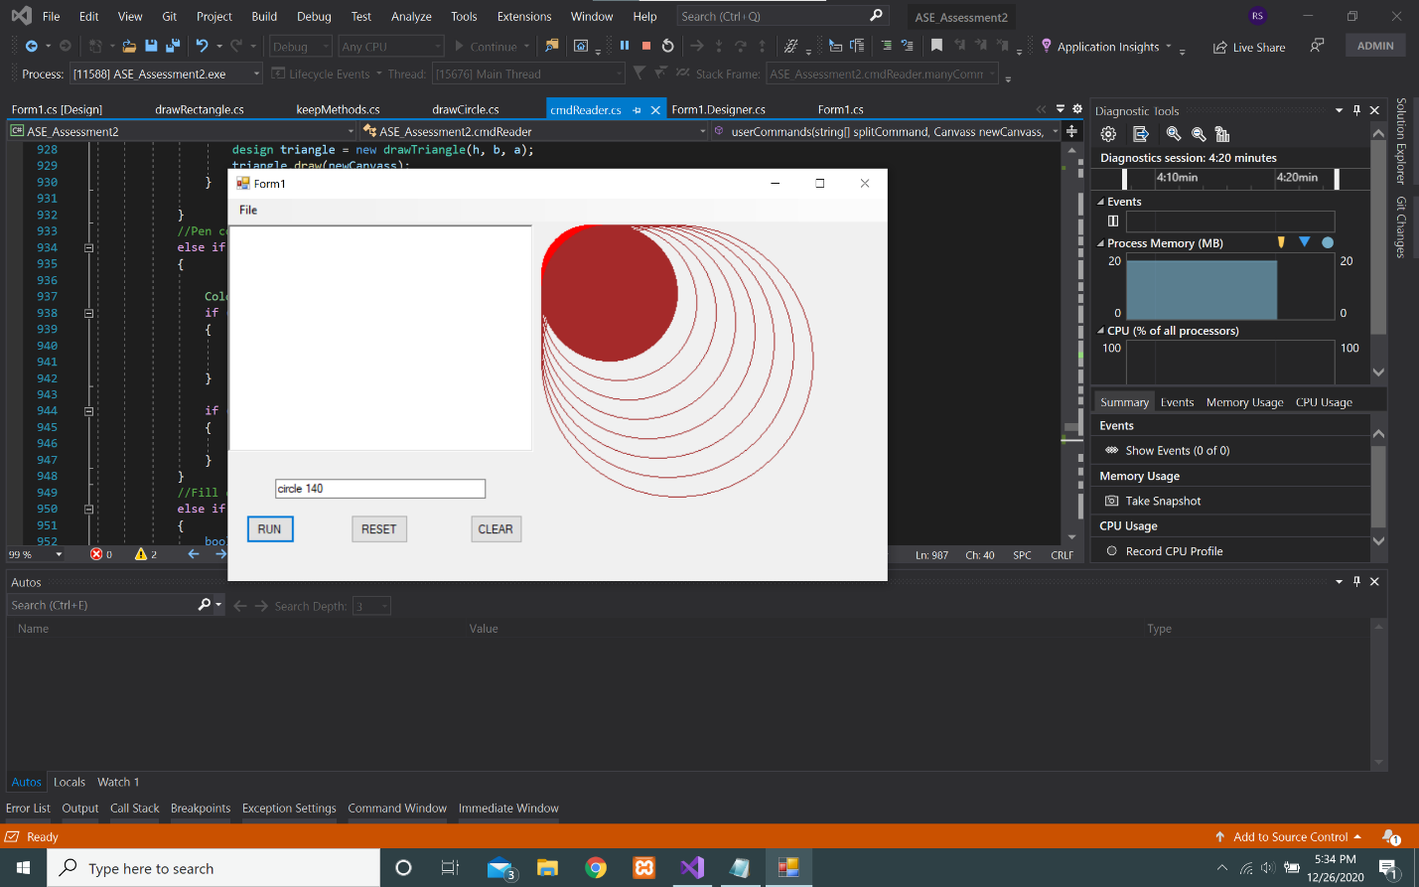

To Load File from file Directory :

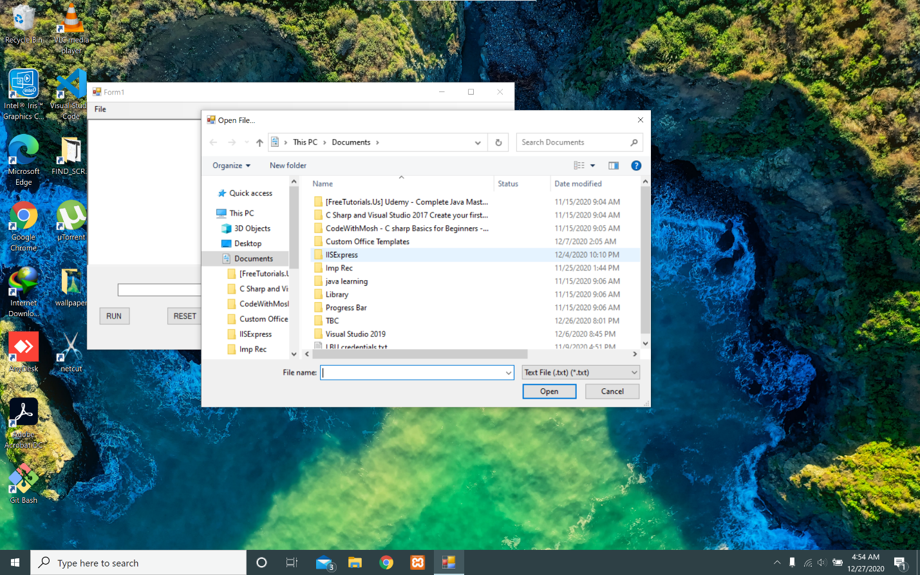

To Save File in file directory:

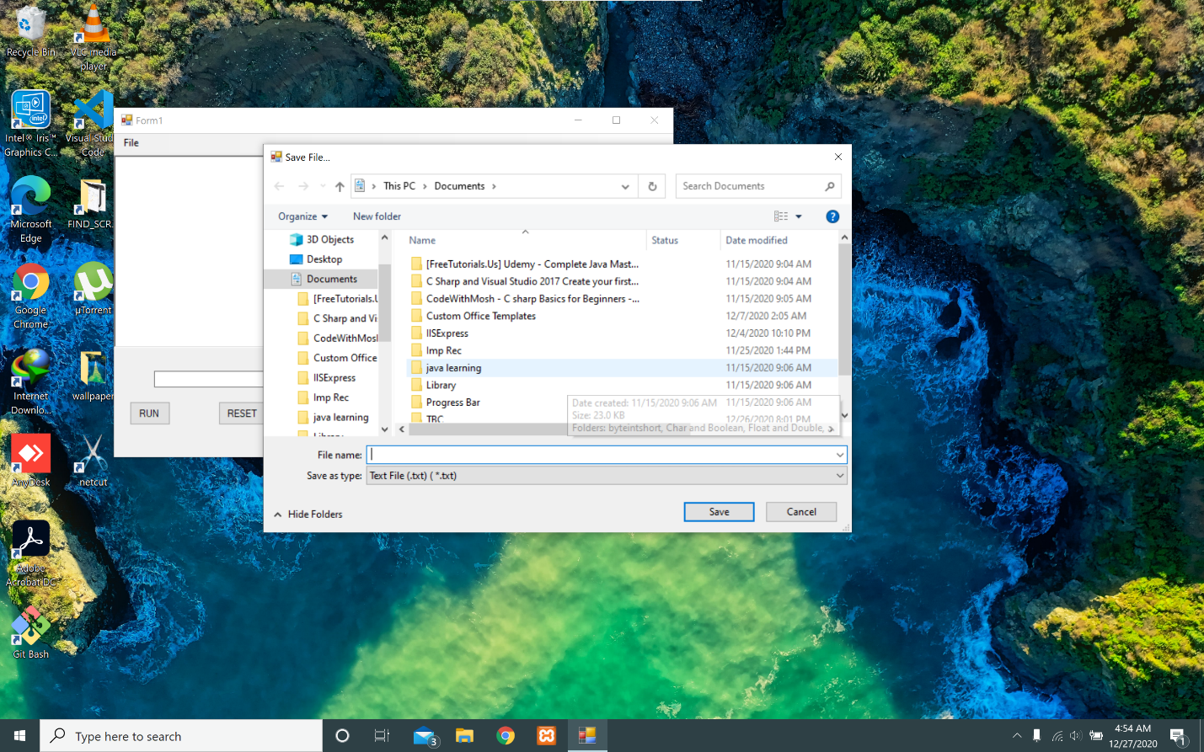

Unit _Testing :

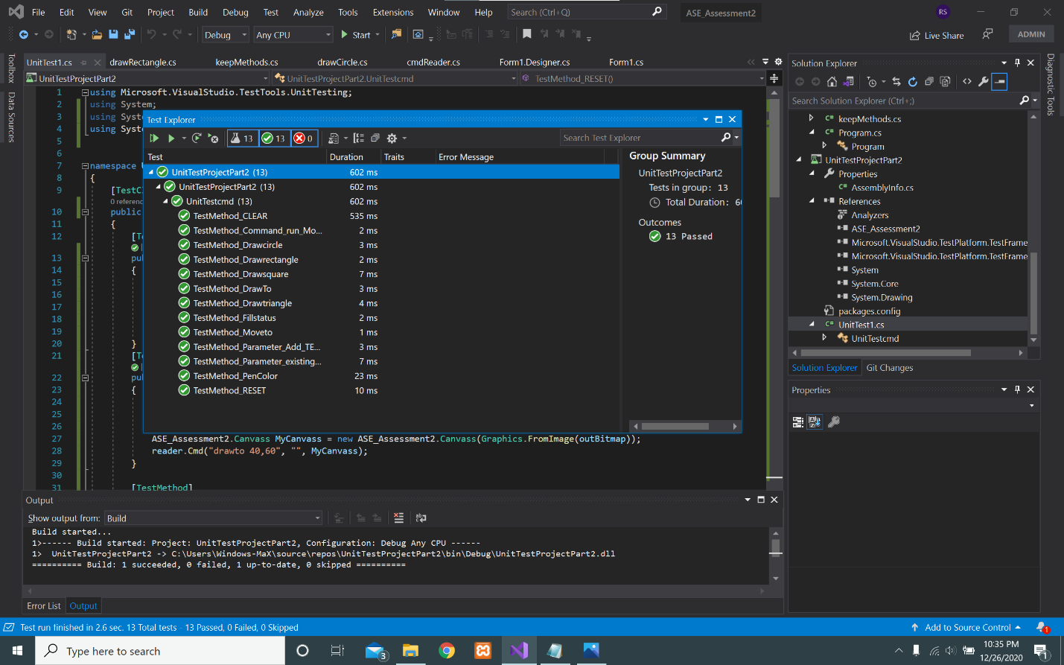

A screenshot of the unit testing performed on Visual Studio 2019.